CALL FOR PAPERS
NOTRE DAME CENTER FOR ETHICS & CULTURE

10th ANNUAL FALL CONFERENCE

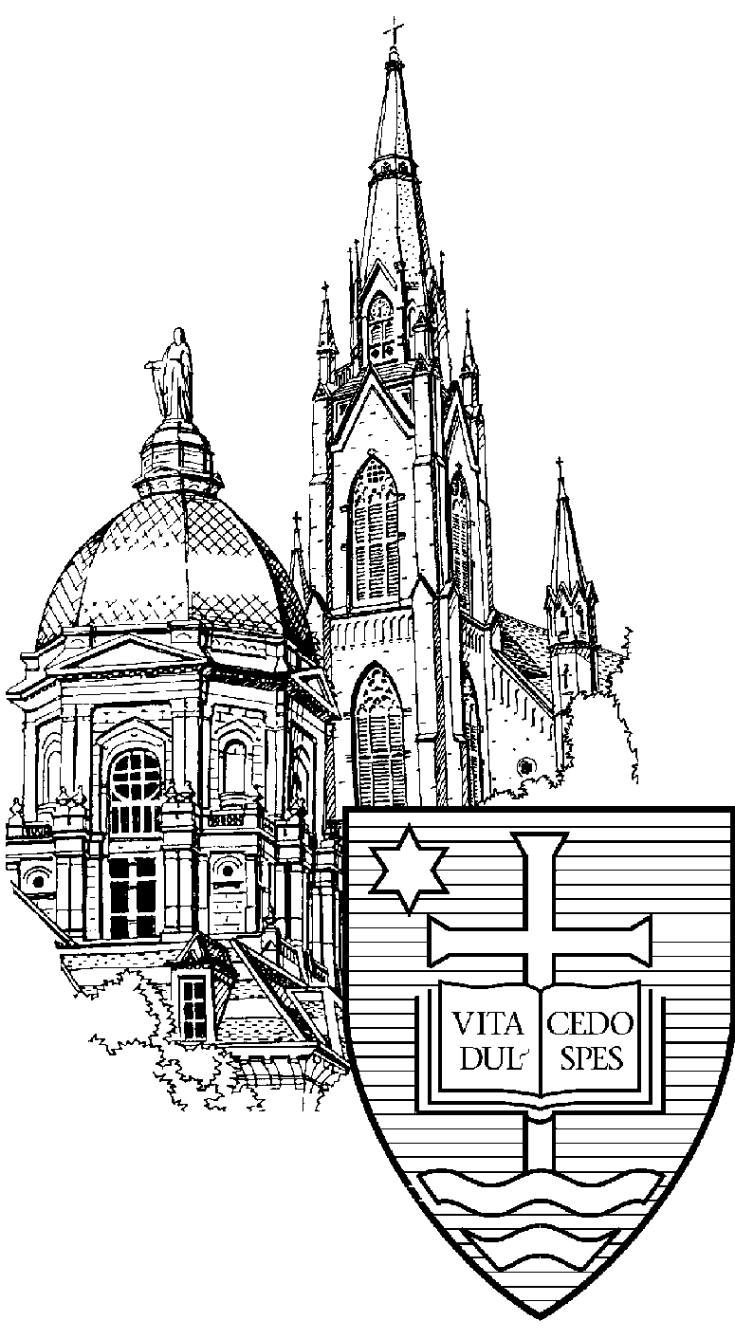

The Summons of Freedom: Virtue, Sacrifice, and the Common Good
November 12-14, 2009

This past November 6-8, the Notre Dame Center for Ethics and Culture hosted its 9th annual fall flagship conference: The Family: Searching for Fairest Love. Toward the end of that weekend we canvassed the opinions of the conference audience regarding themes for the 2009 conference, and, interestingly, a clear consensus emerged. After such a stimulating conference focused on the various threats to the family here at the dawn of the 21st century, many of the conference participants expressed a desire to expand the discussion of family life outward to include the social, political, and spiritual common goods in which the common good of the family is nested. At the same time, there was a clear desire to focus on the virtues as those moral and intellectual habits that allow us to achieve, solidify, and defend the network of common goods in which we human beings realize our happiness. After deliberating on this broad consensus with the staff here at the Center, I concluded that our friends had advised us well. Thus I am delighted to write to you today in order, first of all, to announce the theme for the Notre Dame Center for Ethics and Culture’s 10th annual fall conference: The Summons of Freedom: Virtue, Sacrifice, and the Common Good. The conference will take place November 12-14, 2009, here at the University of Notre Dame.

Final confirmation of the relevance of this conference theme came when we reflected once again upon the remarks made on the South Lawn of the White House by Pope Benedict XVI during his apostolic visit to the United States last April. In those remarks the Holy Father said:

Freedom is not only a gift, but also a summons to personal responsibility. Americans know this from experience—almost every town in this country has its monuments honoring those who sacrificed their lives in defense of freedom, both at home and abroad. The preservation of freedom calls for the cultivation of virtue, self-discipline, sacrifice for the common good, and a sense of responsibility towards the less fortunate. It also demands the courage to engage in civic life and to bring one’s deepest beliefs and values to reasoned public debate.

Here the Holy Father makes clear certain connections that are of utmost importance not only to us Americans, but also to anyone trying to sort through the enormous moral and political complexities of our dizzyingly globalized world. Pope Benedict underscores that freedom is both gift and summons, a call toward a particular “cultivation” or cultural formation in the virtues, virtues that always demand sacrifice—and sometimes even the total sacrifice of one’s life—for the sake of common goods higher than the merely private goods of the self. Earlier in his remarks the Holy Father had emphasized that “the great intellectual and moral resolve” that, in America, ended slavery and brought into being the civil rights movement, took religious belief as a “constant inspiration and driving force,” thus reminding us of Christianity’s role as the true preserver and defender of human freedom. In saying this, the pope invoked his revered predecessor, John Paul II, who tirelessly preached that “in a world without truth, freedom loses its foundation.”

In taking up the theme, The Summons of Freedom: Virtue, Sacrifice, and the Common Good, our 10th annual fall conference will reflect upon political and legal questions having to do with the very nature of the political common good, the particular conflicts that arise in trying to achieve it, and the precarious situation of freedom in the democracies of advanced modernity. But we will also welcome inquiries into social structures other than political ones—such as the arts—in which the virtues may flourish, or which are designed in such a way so as to choke off the development of genuine virtue in favor of ersatz versions. Particular focus will be placed on the analogous forms of virtuous self-discipline and sacrifice required to sustain the human network of common goods.

It is entirely fitting, moreover, that in this tenth anniversary edition of our annual fall conference we will be highlighting the theme of virtue. When, ten years ago, we launched our initial triad of fall conferences—A Culture of Death (2000), A Culture of Life (2001), Agendas for Reform (2002)—we took inspiration in large part from the Center’s senior research fellow, Alasdair MacIntyre, and his hugely influential work in recalling moral philosophy and theology to the tradition of the virtues. How better to celebrate this anniversary edition of the conference than to return to the fountain of Professor MacIntyre’s work for fresh inspiration, especially in the year of his eightieth birthday!

Our aim, as always, is to bring together a large number of respected scholars representing all the main academic fields, from Catholic, Christian, and secular institutions, to engage in a spirited discussion of this theme from the perspectives of philosophy, theology and religious studies, law, history, the social sciences, literature and the arts, as well as other fields of intellectual inquiry and endeavor.

We welcome the submission of abstracts drawing on a wide range of moral and religious perspectives and academic specialties. Special consideration will be given to submissions of ideas for panel discussions that would bring together several people to discuss a focused theme. Possible issues to be explored are:

- the natural law and American democratic government
- analogous senses of the common good
- special demands on courage in contemporary culture
- the multiple threats of individualism
- philosophical and theological inquiries into the virtues
- the riches of Catholic social teaching
- the global economic crisis and the situation of late modern capitalism
- the secularization of contemporary culture
- imagining the common good: what the arts contribute
- the fate of Europe
- stewardship over nature: what does it entail?
- Catholic approaches to the common good: Maritain, McInerny, and MacIntyre
- “Whose common good?”: the unborn, the barely born, the disabled, and the elderly
- freedom and its relation to truth
- Pope Benedict on charity and hope
- the Christian Democratic movement in 20th Century politics
- Elizabeth Anscombe and the virtue revolution in ethics
- the sacrifices of family life

Distinguished speakers invited to the conference include:

- Lucy Beckett
- Michael Novak
- J. Budziszewski
- Alice von Hildebrand
- Rocco Buttiglione
- Russell Hittinger
- Thomas Hibbs
- Fr. Robert Barron
- Richard Garnett
- Robert Sloan
- Michael Baxter
- Mary Keys
- H. Tristram Engelhardt

One-page abstracts for individual papers should include name, affiliation, address, and e-mail address (if available). Session presentations will be limited to twenty minutes for individuals, one hour for panels.

Deadline for submissions is Friday, July 17th. Notification of acceptance will be mailed by Monday, August 4th. One-page abstracts, along with your full contact information, should be emailed to ndethics@nd.edu or mailed to:

Notre Dame Center for Ethics and Culture
10th Annual Fall Conference – The Summons of Freedom
1047 Flanner Hall
Notre Dame, IN 46556

Up-to-date conference information can be found on our web site: http://ethicscenter.nd.edu

